456/2
Mathematics
Paper 2
2 ½ HOURS


ACEITEKA JOINT MOCK EXAMINATIONS 2023
UGANDA CERTIFICATE OF EDUCATION
MATHEMATICS
PAPER 2
TIME: 2 HOURS 30 MINUTES

INSTRUCTIONS TO CANDIDATES
- Answer All questions in section A and any five from section B
- Any additional question(s) will not be marked
- All necessary calculations must be done on the same page as the rest of the answer .Therefore no paper should be provided for rough work.
- Graph papers will be provided.
- Silent, non programmable scientific calculators may be used.

Section A: (40 MARKS)
- Simplify 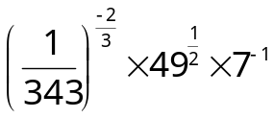
- Use logarithm tables to evaluate 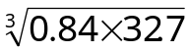 correct to 3 significant figures.
- Express 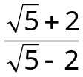in the form 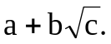Hence state the values of a, b and c.
- Given that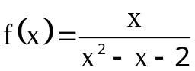. Determine the values of x for which 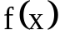is undefined.
- As of May 2017 , Bodox Forex bureau had the following exchange rates .
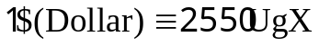and 1£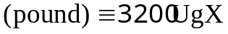.
Ondoga exchanged £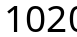in to dollars. How many dollars did he receive?
- Solve the simultaneous equation 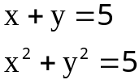
- The coordinates of P and Q are 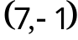and 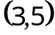 respectively. Given that M is the midpoint of line segment PQ, find;
(a) column vector PM
(b) the magnitude of vector PM correct to 2 decimal places.

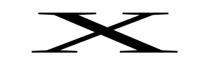



- In the figure below,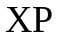is parallel to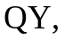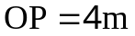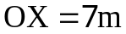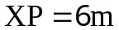 and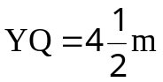.

Calculate the lengths 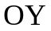and 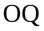
- A map is drawn to a scale of 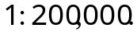Calculate the area of a field in km² that is represented by 2cm² on the map.
- A chord of length 16cm is a way from the centre of a circle; calculate the circumference of the circle. 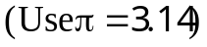

Section B: (60 marks)
Answer any five questions.
- A survey conducted on 30 car owners revealed that 7 liked Ipsum (A) and Premio(B) but not Spacio(C), 5 liked Ipsum and Spacio but not Premio, 2 liked Premio and Spacio but not Ipsum while 3 liked neither of the car models. Those who liked Spacio only were twice those who liked all the 3 models and a third those who liked Ipsum only. $ liked Premio only.
Represent this information on a Venn diagram.
From the Venn diagram, determine the how many people liked;
(i) all the 3 models.
(ii) Spacio.
(iii) Ipsum only.
(c) Find the probability that a person chosen at random from the group liked only one type of car.
- (a) Given that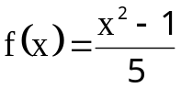, find ;
( i) 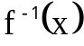
(ii) The values of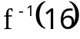.
(b) If 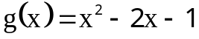and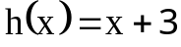, find the value of x for which 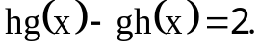

- A plane flew from Entebbe to Nairobi at 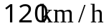for 5 hours on a bearing of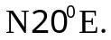 From Nairobi it changes course and flew to Dodoma at a speed of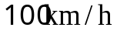 for 3 hours on a bearing of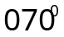. And from Dodoma it flew a further 500km on a bearing of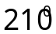 to Kigali.
- Using a scale of 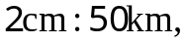draw an accurate diagram showing the journey of the plane.
- Find the distance and the bearing of Kigali from Entebbe from your diagram in (a) above.
- If the plane returned to Entebbe directly from Kigali and took 2 hours, calculate the speed at which the plane flew.

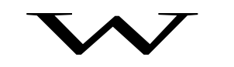





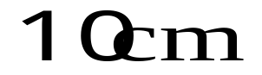
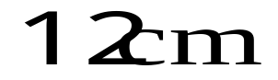
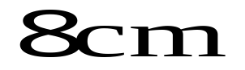
- The figure below PQRSTUVW is a closed box. 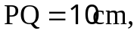 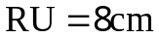and X is a point on 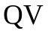such that 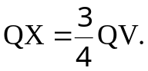

Calculate;
- The lengths 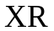and 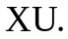
- The angle between and plane 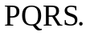
- The angle between and plane
- Kampala is 120km from Masaka.Tom left Kampala for Masaka at 8:15 am riding a motorcycle at 20km/h. Two hours later he stopped for breakfast that took him 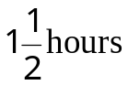before resuming his journey at the same speed.
At 10:30am, Alice left Masaka for Kampala in a vehicle travelling non-stop at a speed of 40km/h.
- Use a scale of 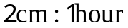on the horizontal axis and 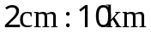on the
vertical axis to draw a distance – time graph for the journeys of Tom and Alice on the same axes.
- Determine from your graph when and where from Masaka Alice met Tom.
- Determine the difference in times of arrival in minutes of the 2 people at
their respective destinations.




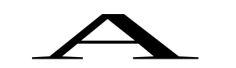

- OABC in the figure below is a parallelogram. P, Q and R are points on OA, OB, and OC respectively such that 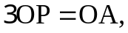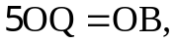and 

Given that 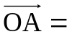̰a and 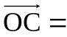̰c
- Express vectors 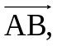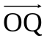and 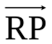in terms of ̰a and ̰b.
- Show that points P, Q and R lie on a straight line.
- The table below shows a tax structure of some country.
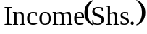 | 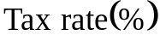
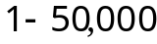 | 
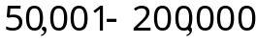 | 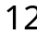
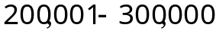 | 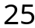
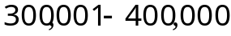 | 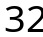
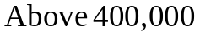 | 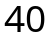

Tax is levied on monthly income after the following allowances have been deducted.
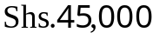for transport,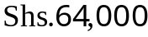for insurance, 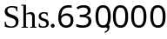annually for feeding, 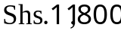for water and electricity, 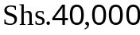for airtime and communication. Family allowances are also offered at the following rates;
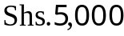for each child below 10 years old and 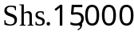for each child aged between 10 and 19 years.
Mr. Oketa earns a gross monthly salary of 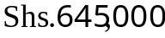and has 5 children aged 7, 12, 18, 22 and 30 years. Family allowance is paid for only 3 children.
Calculate;
- His total monthly allowance.
- His income tax as a percentage of his gross monthly income.
- His net income.

End

